***Program :***

**Industrial Computing and Automation**

***Course :***

**Computer-Aided Design (CAD)**

***Project :***

**Three-Tank Liquid Level System**

**Prepared by :**

* Zitouni Malek
* Mohammed karim ben boubaker
* Maysaa Fezai



# Benchmark Description

The three-tank system is an industrial benchmark for studying control challenges in MIMO (Multi-Input Multi-Output) systems. This project aims to model, control, and analyze such a system by integrating PID regulators and simulation tools.

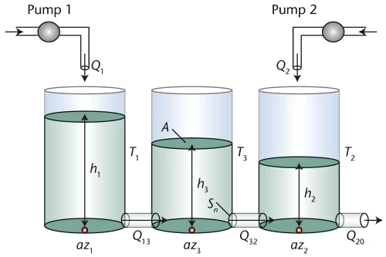

The system parameters and its variables are listed in Table T1 :

| **Parameter** | **Description** | **Unit** |
| --- | --- | --- |
|  | Water height in tank i (i=1,2,3) | m |
|  | Pump j flow rate to tank j (j=1,2) | m³/s |
|  | Flow rate from tank 1 to tank 3 | m³/s |
|  | Flow rate from tank 3 to tank 2 | m³/s |
|  | Flow rate from tank 2 to reservoir | m³/s |
| S | Cross-sectional area of tanks 1,2,3 | m² |
|  | Orifice cross-sectional area | m² |
|  | Flow coefficients (i=1,2,3) | - |
| g | Gravitational coefficient | m/s² |

*Table T1*

##### **Significance of the Three-Tank System in:**

* **Industrial Applications** :
  + **Fluid management systems** (water, petroleum, chemical processing).
  + **Control strategy testing** for coupled dynamics and disturbance rejection.
  + **Energy sector applications** (nuclear coolant control, hydroelectric systems, biofuel blending).
  + **Pharmaceutical/biotech uses** (vaccine production, sterile water distribution).
* **Modern Process Control** :
  + **Validation platform** for robust control algorithms (PID, Model Predictive Control).
  + C**omplex interaction simulation** between process variables (level, flow rate).
  + **Digital twin development** (virtual replica for failure mode testing).

# Modeling Using Torricelli's Law

**To demonstrate :**

**With consideration of :**

**Demonstration :**

Water volume variation rate V for each tank :

=

V = S×h

Which leads to :

= (

|  | **Tank 1** | **Tank 2** | **Tank 3** |
| --- | --- | --- | --- |
|  |  |  |  |
|  |  |  |  |

*In and Out tank flows*

Then :

# Complex Nonlinearities

This system exhibits several sources of complex nonlinearities:

1. **Square root dependence** of flow rates on height differences.
2. **Sign function (sgn)** introducing a discontinuity when height differences change sign.
3. **Strong coupling** between tanks via flow rates *Q*13​ and *Q*32​:Changes in one tank propagate to others.
4. **Dynamic interdependence**, where variations in one tank affect the others.
5. **Different behavior** depending on flow direction (ℎ1>ℎ3*h*1​>*h*3​ vs. ℎ1<ℎ3*h*1​<*h*3​).
6. **Control Design**: Requires nonlinear methods (e.g., feedback linearization, sliding mode control, or adaptive control).
7. **Real-World Behavior: Explains why such systems exhibit oscillations, slow settling times, or sensitivity to initial conditions.**

# Benchmark on Physical Scale Model

# LabVIEW Implementation

* Front Panel :

**Controls:** Setpoints href, PID Parameters

**Indicators:** Level graphs, Flow rates (Q1, Q2)

* Block Diagram :

**PID loops** implemented with PID Advanced.vi

* ***Front Panel***

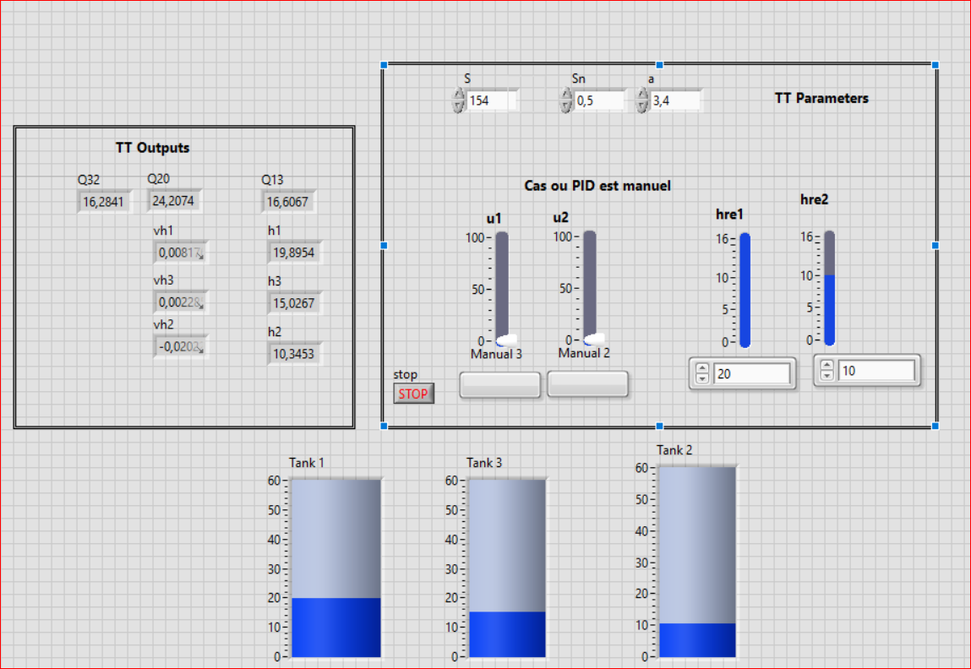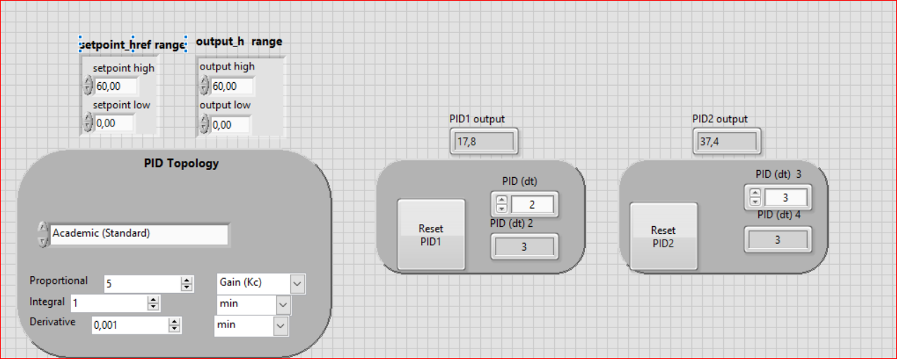

* ***Block Diagram***

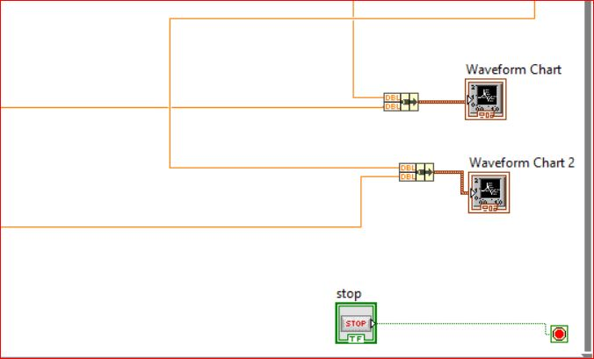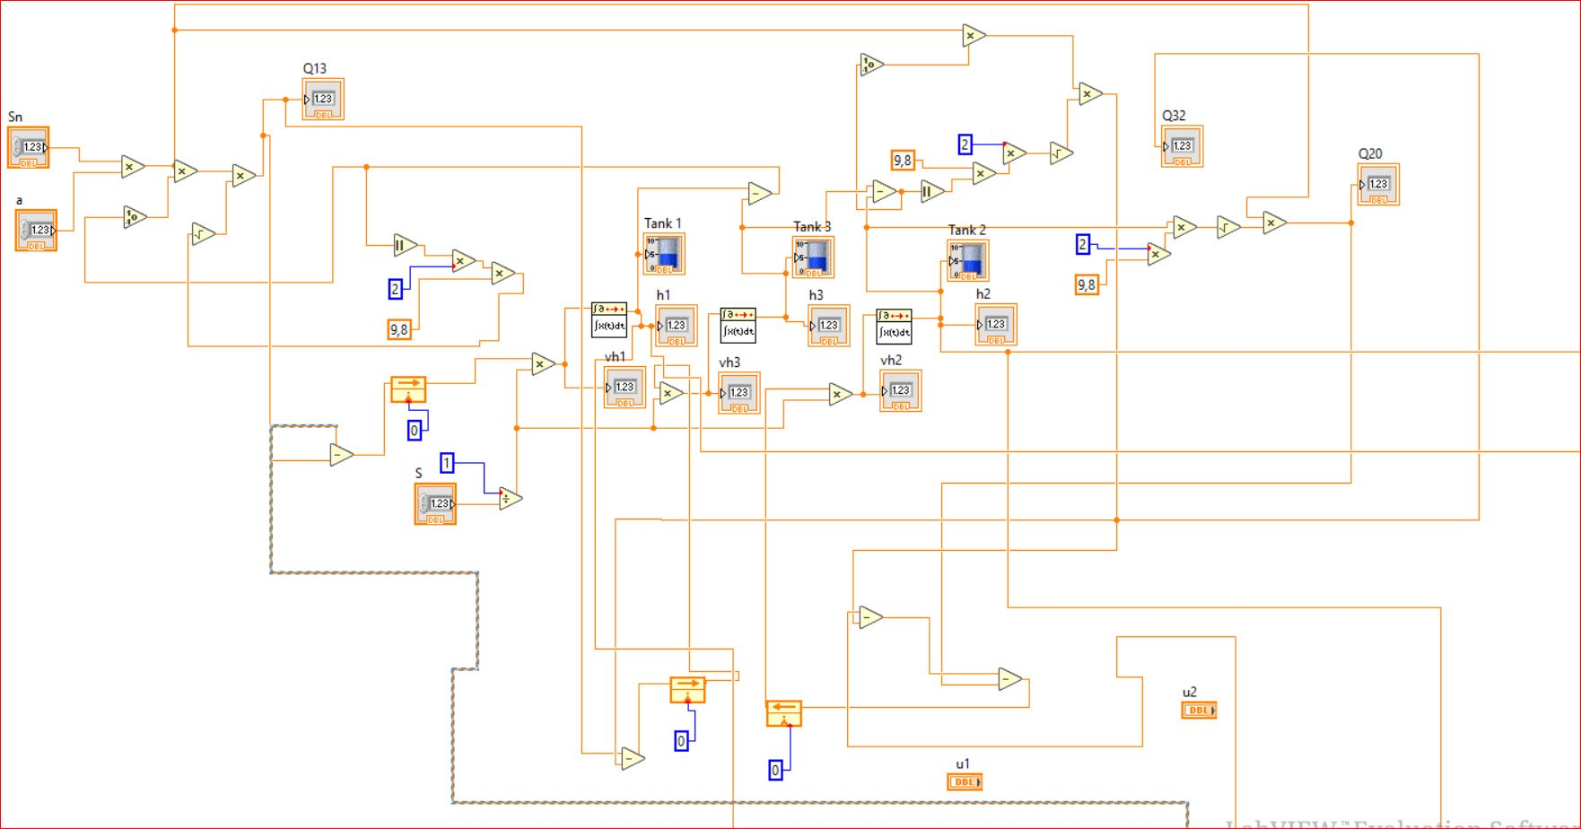

## PID Control

##### **PID advanced VI :**

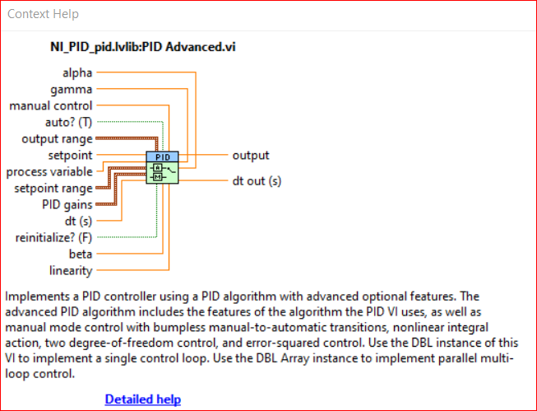

***PID advanced VI***

**General Principle of Control :**

**Objective:** Achieve ℎ=ℎref​ (maintain liquid levels at reference setpoints).  
with varying of *Qi*​

### **Manual Mode (Q1 and Q2 are fixed by the user) :**

* + Liquid levels evolve **naturally** according to the system's **Torricelli-based dynamics** (square-root flow laws).
  + **No feedback correction** is applied—the error e=ℎref−ℎis **ignored**.
  + The user must **manually guess and set** fixed flow rates to reach desired levels.
  + **No stability guarantee**: Levels may diverge or oscillate unpredictably due to:
    - * Nonlinear flow coupling between tanks.
      * Sensitivity to initial conditions.

**Automatic Mode (PID Regulation) :**

The **PID controller** provides **closed-loop feedback control**, dynamically adjusting pump flow rates (*Q*1​,*Q*2​) to maintain liquid levels (ℎ1,ℎ2,ℎ3) at their desired **setpoints** (*href*​) : 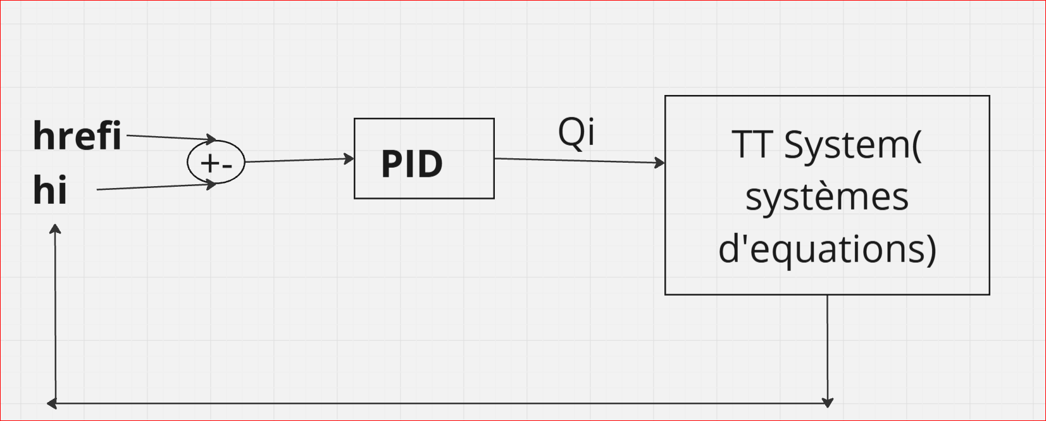

***PID controller***

#### **PID Control Equations** :

**: Proportional Gain**

* **Role: Reacts to the current error e(t)=ℎref−ℎ(t)**
* **Effect:**
  + **High ​: Faster response but risks overshoot/oscillations.**
  + **Low** **​: Slower convergence (may not correct errors quickly)**

**:  Derivative Gain**

* **Role: Anticipates future errors by reacting to the error’s rate of change**
* **Effect:**
  + **High  ​: Dampens oscillations but amplifies sensor noise.**
  + **Low  : Poor damping (levels may oscillate around *h*ref​).**

**:** **Integral Gain**

* **Role**: Eliminates **steady-state error** by integrating past errors ∫*e*(*t*)*dt*.
* **Effect**:
  + **High** :Faster elimination of small residual errors but may cause **integral windup** (unstable growth).
  + **Low** :Persistent small deviations (e.g., never quite reaching *h*ref​).

**In this case, the flow of every tank can be expressed by the following equation :**

**Why these gains matter in our system** :

* **Nonlinear flows**:  must compensate for *hi*​−*hj*​​ effects.
* **Coupling**: ​ mitigates interactions between tanks.
* **Setpoint Changes**:  ensures no residual error after transitions.

#### **PID Advantages** :

* **Stability:**

Handles **strong coupling** (Tank 1 ↔ Tank 3 ↔ Tank 2).

Rejects **unexpected disturbances** (e.g., sudden flow changes).

* **Precision:**

Integral action eliminates steady-state error (unlike manual mode).

Robust to Torricelli’s nonlinearity ( (*hi*​−*hj*​) )

* S**peed**: **Proportional + Derivative** terms ensure fast, oscillation-free response.

**PID Regulation Process:**

**1. Initialization**

* Set the reference level (*h*ref​) for each tank.
* Switch to automatic mode to enable PID control of flow rates (*Qi*​).

**2. Real-Time Control Loop**

* Measurement: LabVIEW reads liquid heights (*hi*​) from sensors.
* Error Calculation: Computes tracking error:

***ei*​(*t*)=*h*ref,*i*​−*hi*​(*t*)**

**3. PID Action: Adjusts pump flows (*Qi*​) to minimize error:**

***Qi*​(*t*)=*Kp* ​*ei*​(*t*)+*Ki* ​∫*ei*​(*t*)*dt*+*Kd*​**

**4. Optimization: Tune *Ki*​ to:**

* + **Eliminate steady-state error (e.g., residual deviation).**
  + **Avoid integral windup (use anti-windup in PID Advanced.vi).**

**Key Adjustments :**

* **For slow response: ↑ *Kp*​ or *Ki*​.**
* **For oscillations: ↑ *Kd*​ or ↓ *Kp*​.**

# Conclusion

La mise en œuvre d’un système de régulation PID sur le modèle physique de trois cuves a permis de valider l’efficacité du contrôle automatique par rapport au mode manuel. Grâce à l'intégration du logiciel LabVIEW et des boucles PID avancées, le système a pu maintenir les niveaux d’eau à leurs valeurs de consigne malgré les non-linéarités et les interactions complexes entre les cuves. Les résultats obtenus confirment l’importance d’un réglage adéquat des gains PID (Kp, Ki, Kd) pour garantir stabilité, rapidité de réponse et élimination de l’erreur statique. Toutefois, afin d’atteindre des performances optimales, un **fine-tuning précis** des paramètres PID est nécessaire. Dans certains cas, il peut également être judicieux d’envisager l’utilisation d’un **régulateur plus avancé** (comme un contrôle prédictif ou adaptatif) pour mieux gérer les non-linéarités et les couplages dynamiques du système.